CSIT314 Software Development Methodologies - Group Project

Sprint 3 - US31: Search IDPs
Interior Design Platform - Customer
All diagrams were drawn in draw.io. Open "US31 Search IDPs.drawio" in this folder to edit them - each diagram is its own page in that file. The exported images are in the "diagrams" folder.

Assumptions
- The system is the Interior Design Platform from the project specification. Sprint 3 covers the Interior Designer's current IDP stories (US20 - US24) and the Customer's log in, search IDPs, view IDP and log out stories (US30 - US32, US36).
- We follow B-C-E: the actor only talks to the boundary (page), the boundary only talks to the controller, and the controller works with the entity classes. There is one controller per use case.
- Who checks what: the page trims the spaces from the keyword - there are no other input rules (an empty keyword lists every IDP). SearchIDPController.searchIDPs(keyword) just calls the entity and returns the list - no checks and no trimming. IDP.searchIDPs(keyword) picks the IDPs a customer can see and matches the keyword; it doesn't trim the keyword.
- Being logged in as a Customer (UC30) is the precondition, so the page and the diagrams don't check the customer again (no CustomerLoginController, no customerId). customerLoginRequired in app.py only sends someone with no session to /customer/login.
- The customer catalogue is every Active IDP in an Active category, from every designer, both Current and Past. Suspended IDPs and IDPs in a Suspended category are left out.
- The keyword matches the title, description, location or category name. Capitals are ignored (Unicode case folding); accents are not removed and several words count as one piece of text.
- An empty keyword (or only spaces) lists every IDP the customer can see. Clear removes the keyword. Results are newest first and each IDP appears once.
- %, _, quotes and backslashes are searched as normal characters; the keyword is passed to the database as an SQL parameter.
- Each card shows the title, category, location (if any), project type and a short description (200 characters). "No matching IDPs found" (MSG_NO_RESULTS, keyword given) and "No IDPs are currently available" (MSG_NO_IDPS, empty keyword) are normal pages (HTTP 200).
- Searching never changes any data and is not counted as a view. Viewing an IDP is US32 and saving it is US33.

1. User story
Story ID | US31
User story | As a customer, I want to search for IDPs so that I can find designs I like.
Actor | Customer
Priority | Medium
Story points (estimate) | 2
Acceptance criteria | 1. Given I am logged in as a customer, I can open Search IDPs from the dashboard or the sidebar.  2. Given I type a keyword and click "Search", then I see the IDPs whose title, description, location or category contains it (capitals and spaces around the keyword are ignored).  3. The results include Active Current and Past IDPs from every designer, in Active categories only, newest first, each one once.  4. Given I leave the keyword empty or click "Clear", then I see every IDP I can view.  5. Given nothing matches, I see "No matching IDPs found"; given there are no IDPs at all, I see "No IDPs are currently available".  6. Given I am not logged in, when I open Search IDPs, then I am sent to the customer login page.
Tasks | T31.1 Write the use case description and draw the use case diagram  T31.2 Draw the B-C-E class diagram and the sequence diagram  T31.3 Draw the wireframes for browsing, matching designs, no matches and an empty catalogue  T31.4 Write the unit tests first (TDD) for IDP.searchIDPs(), SearchIDPController and SearchIDPPage  T31.5 Code IDP.searchIDPs(keyword) (the customer catalogue, no trimming)  T31.6 Code SearchIDPController.searchIDPs(keyword) (just calls the entity) and SearchIDPPage (trims the keyword, shows the cards or the messages)  T31.7 Put customerLoginRequired on /customer/idps/search (it only redirects when there is no session)  T31.8 Run the test cases, fix bugs and push to the repo so the CI pipeline runs the unit tests

2. Use case diagram
The user story becomes one use case, UC31 Search IDPs. The Customer is the only actor. Being logged in (UC30) is the precondition; viewing and saving an IDP are separate use cases (UC32, UC33).
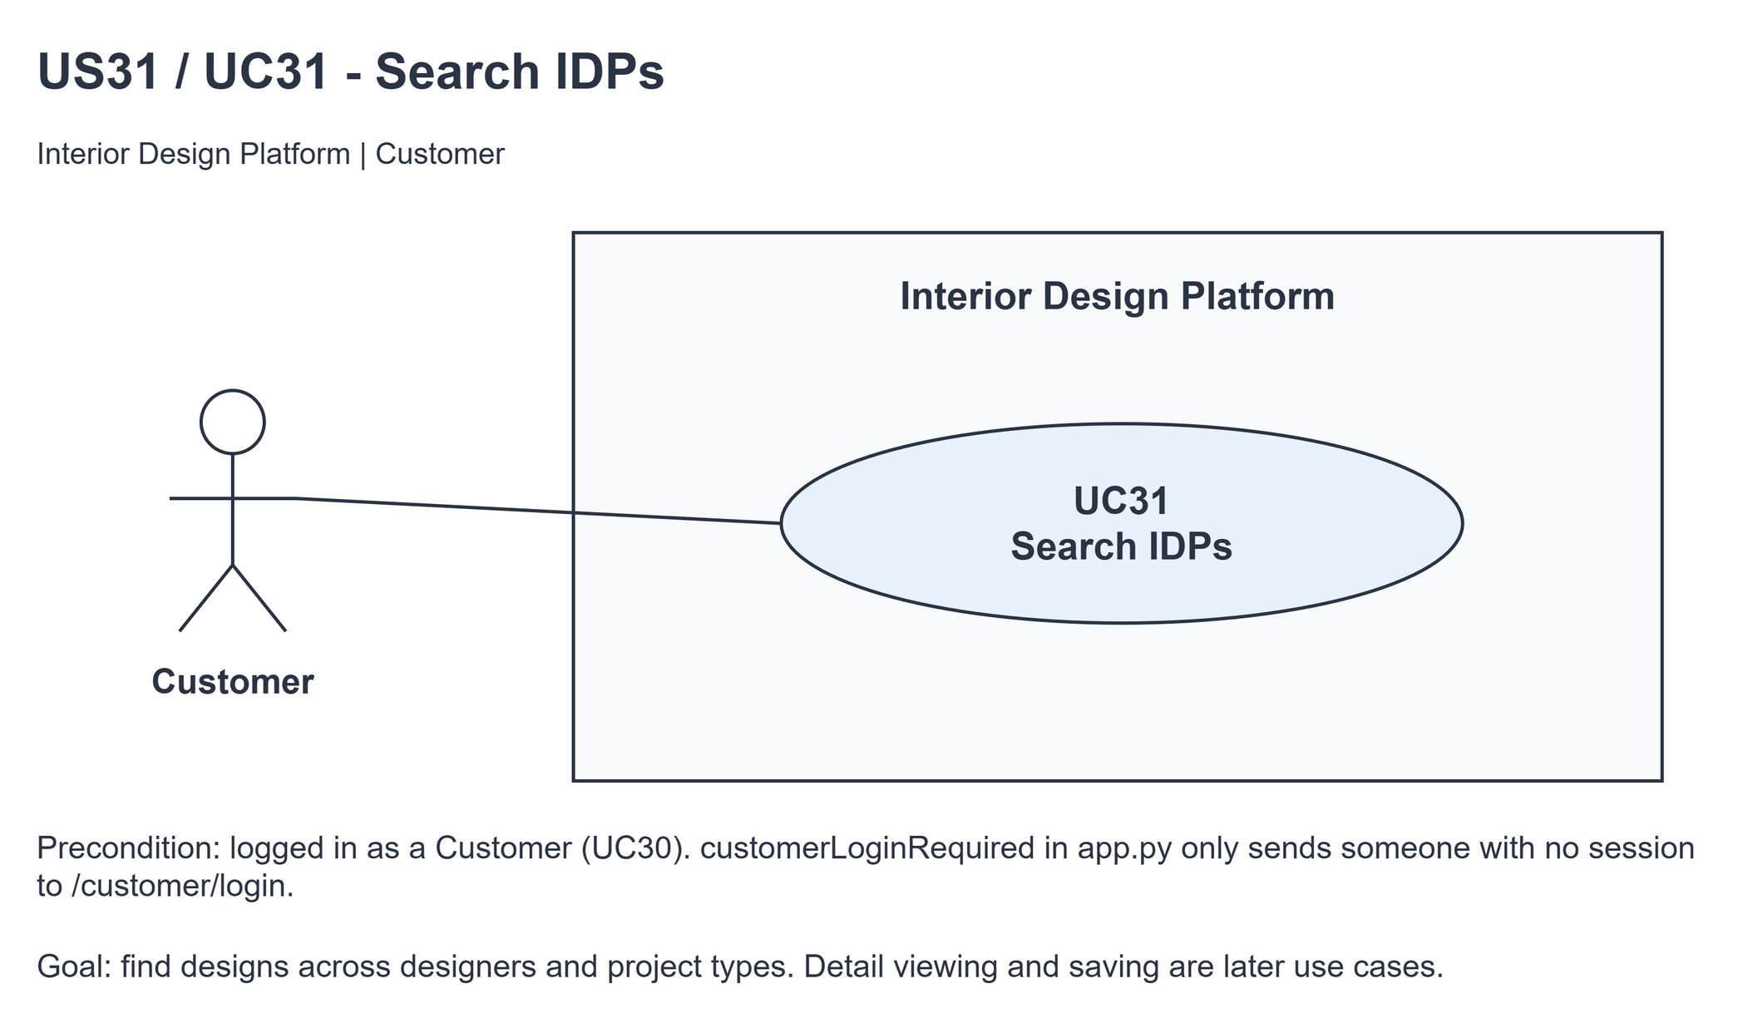
Figure 1: Use case diagram for US31 Search IDPs

3. Use case description
Use case | UC31 Search IDPs
Actor | Customer
Brief description | The Customer searches the IDPs from all designers to find designs they like.
User story | US31: As a customer, I want to search for IDPs so that I can find designs I like.
Preconditions | The Customer is logged in (UC30).
Trigger | The Customer clicks Search IDPs on the dashboard or the sidebar, or submits the search form.
Basic flow | 1. The Customer opens Search IDPs.  2. The Customer types a keyword and clicks "Search".  3. The system trims the spaces from the keyword.  4. The system finds the Active IDPs in Active categories (Current and Past, from every designer) whose title, description, location or category name contains the keyword, newest first.  5. The system shows the matching IDP cards and keeps the keyword in the search box.
Alternative flows | 2a. The keyword is empty or the Customer clicks "Clear": the system lists every IDP the Customer can view.  5a. Nothing matches the keyword: the system shows "No matching IDPs found".  5b. The keyword is empty and there are no IDPs to show: the system shows "No IDPs are currently available".
Postconditions | The matching IDPs (or a message) are shown. No data is changed.

4. Wireframes
The wireframes were drawn in draw.io. They are low-fidelity: they show the layout and the flow, not the final colours. They follow customerBase.html, customerSearchIDPs.html and static/style.css.

4a - Browse available designs
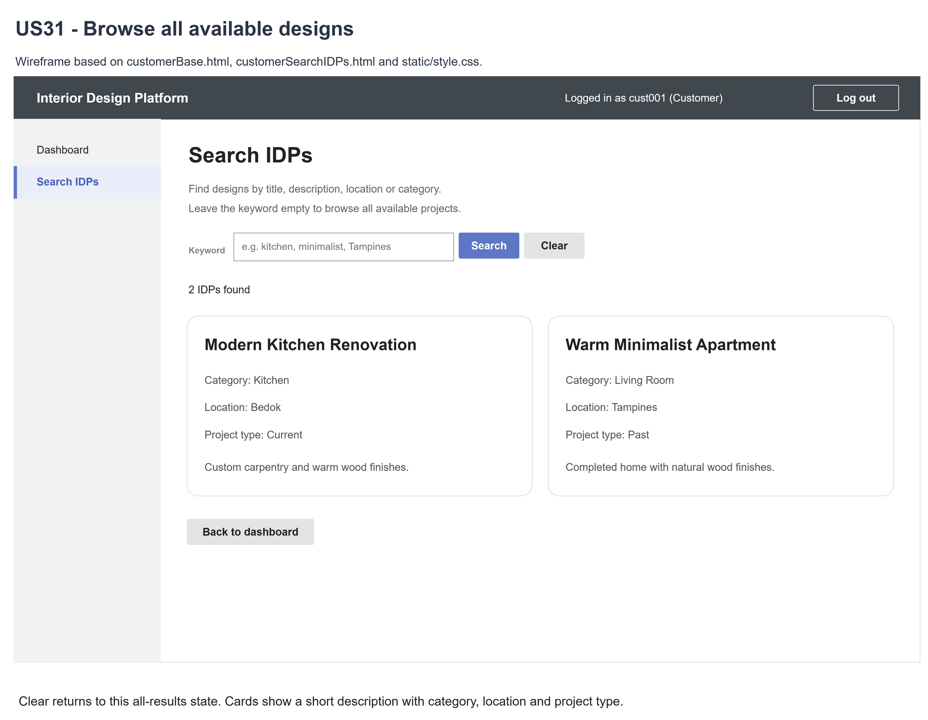
Figure 2: Wireframe 4a - Browse IDPs (US31)

4b - Matching designs
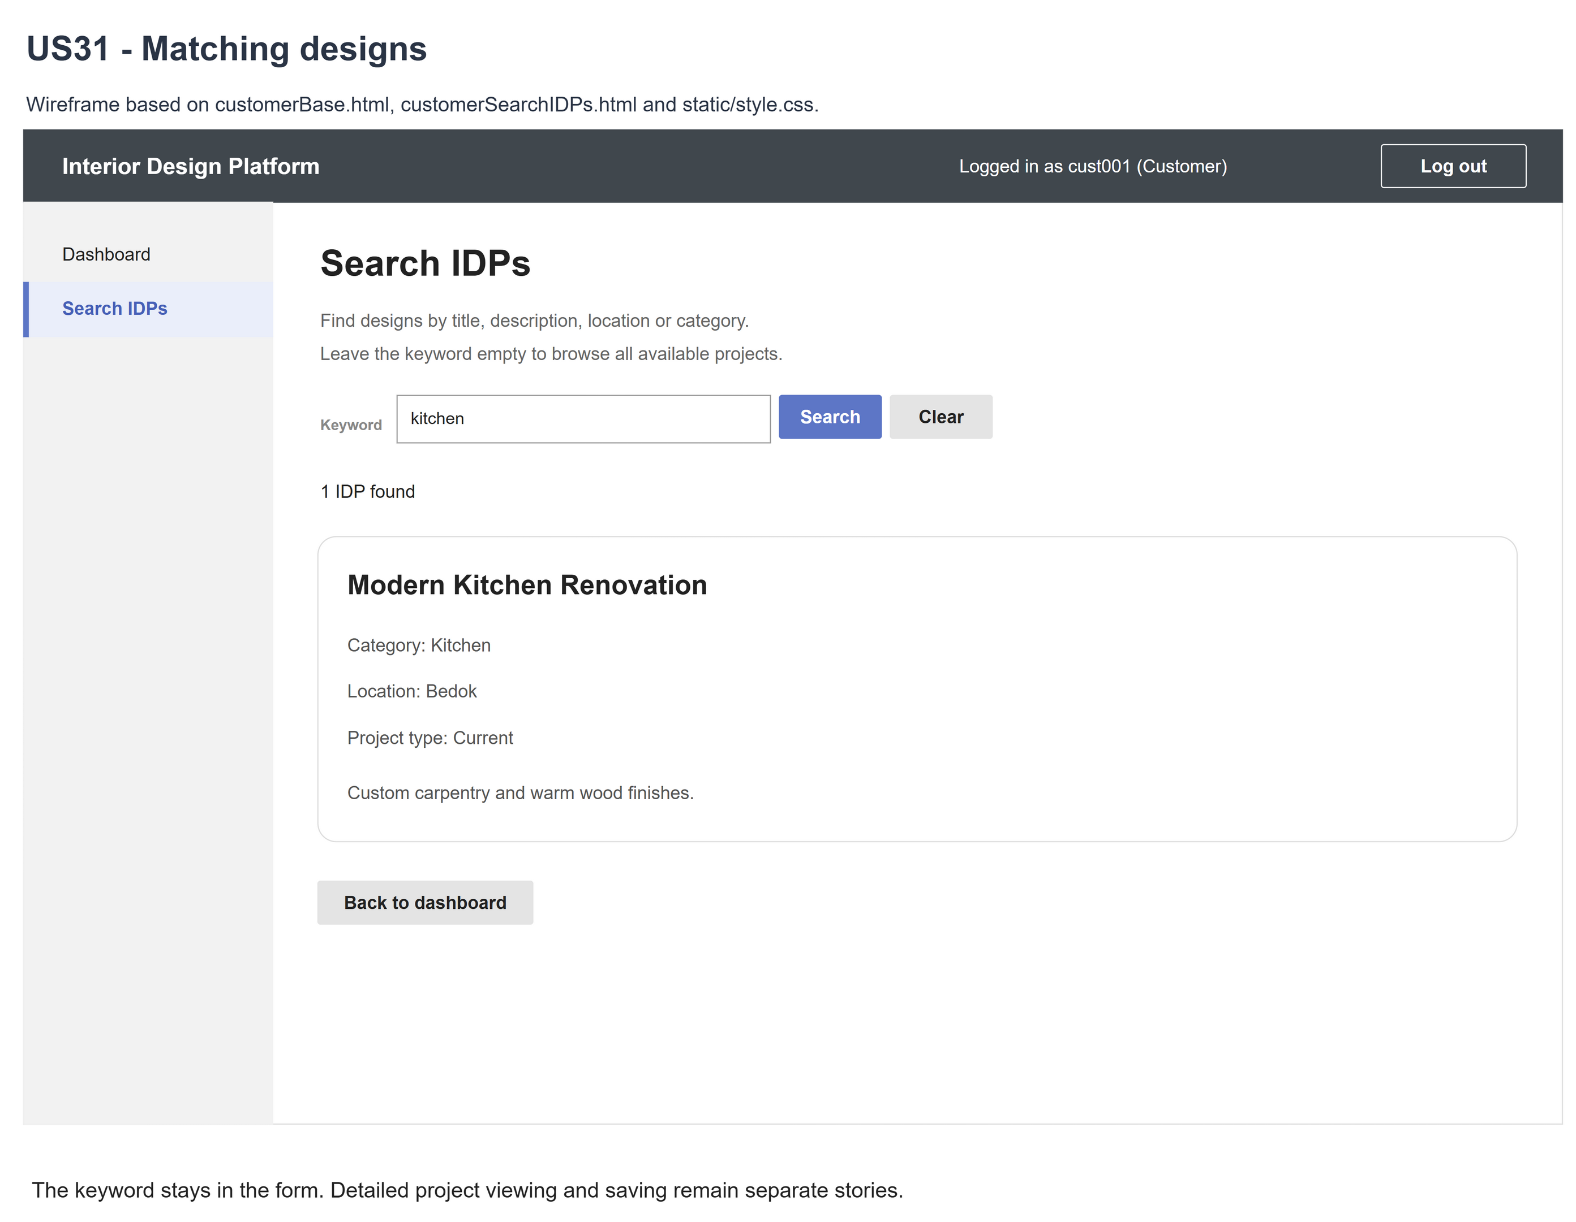
Figure 3: Wireframe 4b - Matching designs (US31)

4c - No matching designs
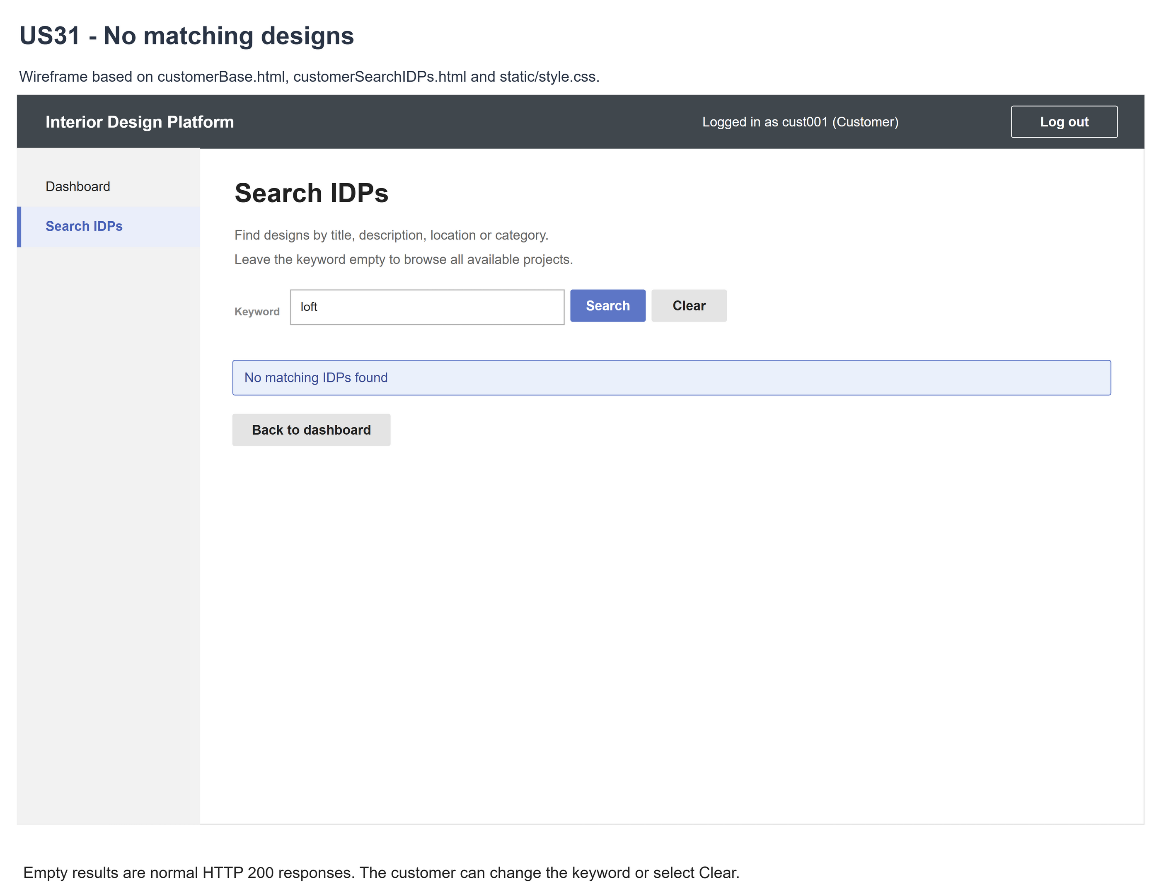
Figure 4: Wireframe 4c - No matching designs (US31)

4d - Empty catalogue
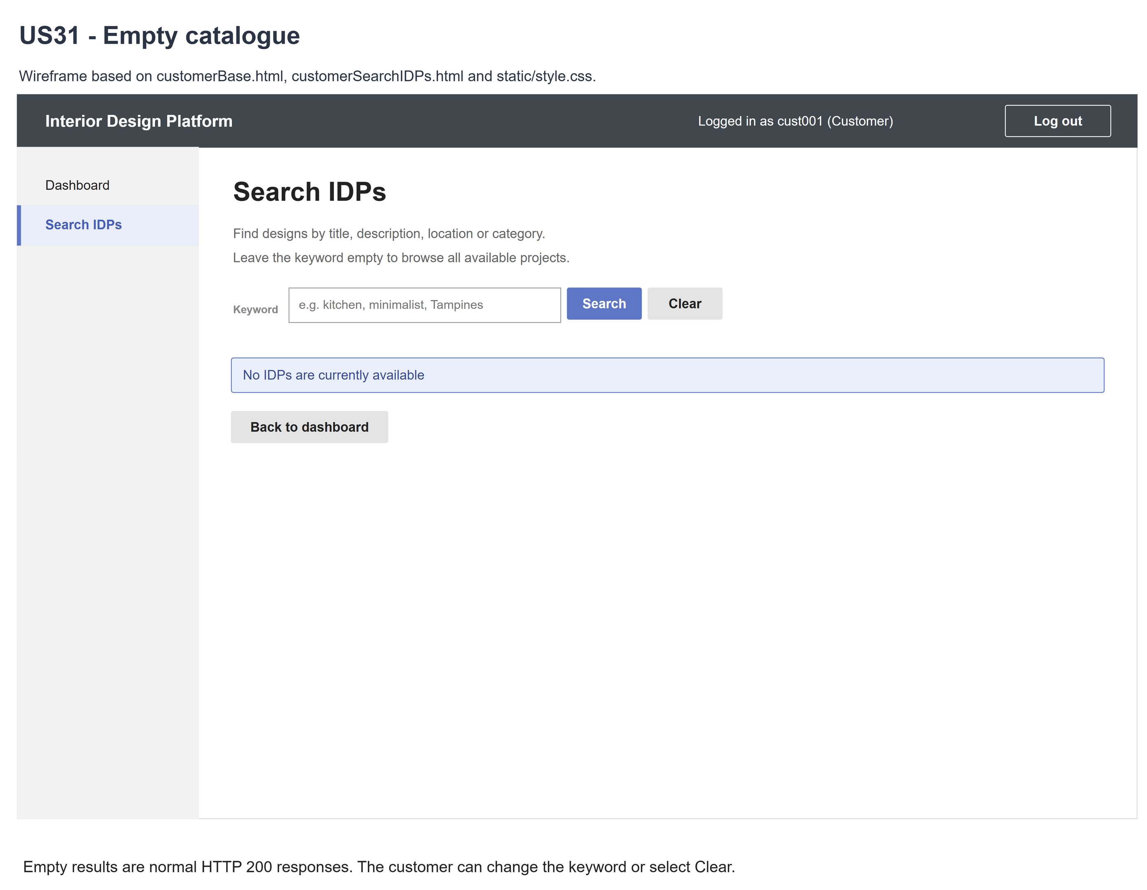
Figure 5: Wireframe 4d - Empty catalogue (US31)

5. B-C-E class diagram
The solid line means the boundary calls the controller. The dashed line means the controller uses the entity class. Only the operations needed for this use case are shown, with the same names as the code.
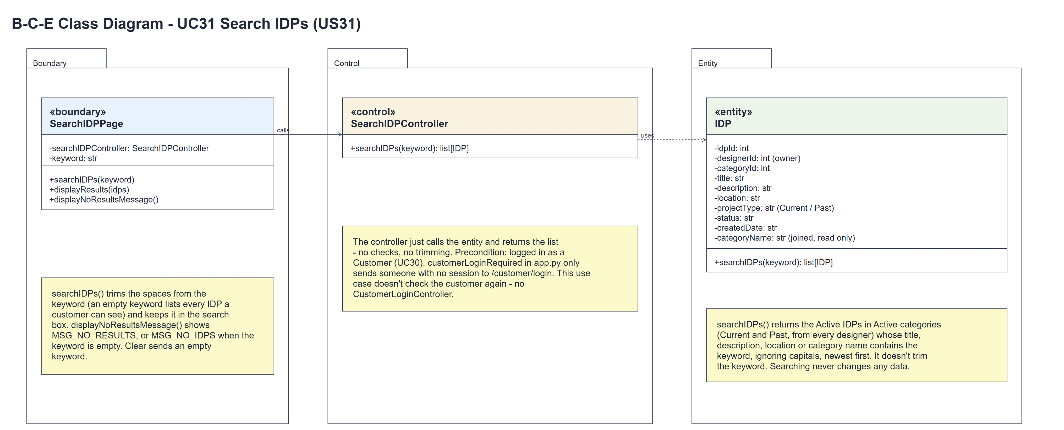
Figure 6: B-C-E class diagram for US31 Search IDPs
Layer | Class | What it does
Boundary | SearchIDPPage | The search page. searchIDPs(keyword) trims the keyword, calls the controller and shows the result: displayResults(idps) for the cards, or displayNoResultsMessage() for MSG_NO_RESULTS (MSG_NO_IDPS when the keyword is empty).
Control | SearchIDPController | Controller for UC31. searchIDPs(keyword) just calls IDP.searchIDPs(keyword) and returns the list - no checks.
Entity | IDP | The only entity. searchIDPs(keyword) returns the Active IDPs in Active categories (Current and Past, every designer) whose title, description, location or category name contains the keyword, ignoring capitals, newest first. categoryName is joined from idp_category.

6. Sequence diagram
The sequence diagram follows UC31. The page trims the keyword (step 2) and calls the controller, which just calls the entity (steps 3-6). The alt shows the two endings: the matching IDP cards, or the no-results message (MSG_NO_IDPS when the keyword is empty). Searching has no input rules, so there is no [input is valid] alt.
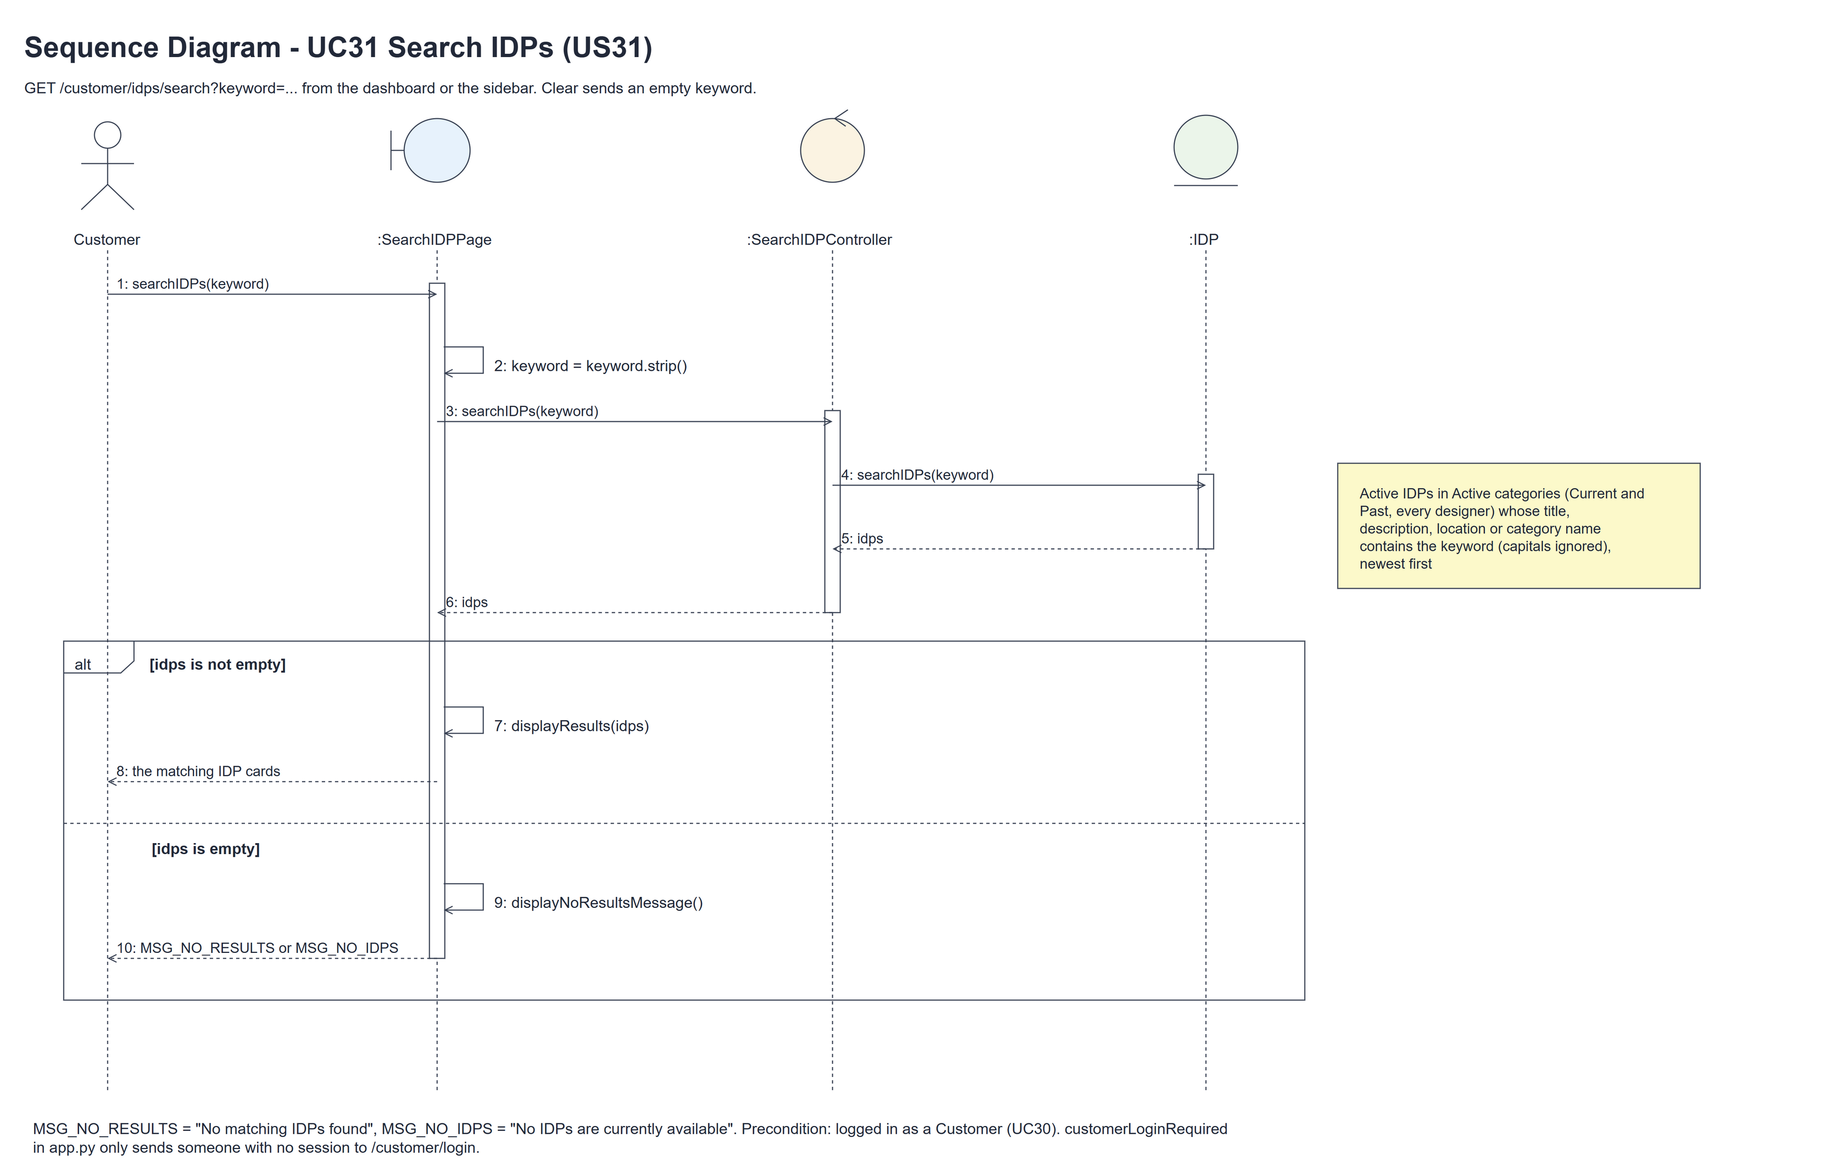
Figure 7: Sequence diagram for UC31 Search IDPs

7. Test cases
Test data used below (same as the test file): two interior designers with Current and Past IDPs, Active and Suspended IDPs and categories, and the customer cust001 / Cust@123. The search words cover the title, description, location, category, Unicode and characters such as % and _. Tests use an isolated database.

7a. System test cases (black box)
Equivalence partitioning and boundary value analysis were used to pick the test data. Fill in "Actual result" and "Pass/Fail" after running each test.
Test ID | Scenario | Prerequisites | Test steps | Test data | Expected result | Actual result | Pass / Fail
TC31.1 | Title / description | Matching projects exist. | Search each field. | Renovation; carpentry | Correct matching design cards.
TC31.2 | Location / category | Projects in two categories. | Search each field. | Bedok; Living Room | Correct location/category matches.
TC31.3 | Case / whitespace | Matching project exists. | Search padded mixed case. | KITCHEN | Trimmed, case-folded matches.
TC31.4 | Browse / Clear | Visible projects exist. | Search; Clear or submit spaces. | Empty; spaces | All available designs, newest first.
TC31.5 | Across designers | Two designers have IDPs. | Search common term. | Shared description | Both designers can appear.
TC31.6 | Project types | Current and Past IDPs. | Browse catalogue. | Current; Past | Both types included.
TC31.7 | Visibility | Mixed project/category status. | Search common term. | Active; Suspended | Only Active IDPs/categories.
TC31.8 | No matches | No matching projects. | Search unknown term. | unmatched-zebra | HTTP 200; message; keyword retained.
TC31.9 | Empty catalogue | No visible projects. | Open empty search. | No keyword | HTTP 200; empty-catalogue message.
TC31.10 | Not logged in | Signed out. | Open /customer/idps/search. | No session | Sent to the customer login page.
TC31.11 | Fresh data | Customer can search. | Update/hide IDP; search again. | Changed project | Latest saved results.
TC31.12 | Safe / read only | Customer can search. | Try literal/script text; compare DB. | %, _, quote, script | Escaped/literal; no writes.

7b. Unit test cases (for TDD)
These are written before the code (test-driven development) and run automatically in the CI pipeline. They cover normal inputs, abnormal inputs and boundary values. Each one matches a test function in tests/test_us31_searchIDPs.py (UT31.1 is test_ut31_1_...). Controller means SearchIDPController; Boundary means SearchIDPPage. "Pass" is from the pytest run on 10 November 2026.
Test ID | Class and method | Input / setup | Expected output | Type | Pass / Fail
UT31.1 | IDP.searchIDPs() | Title substring. | Matching project. | Normal | Pass
UT31.2 | IDP.searchIDPs() | Description substring. | Matching project. | Normal | Pass
UT31.3 | IDP.searchIDPs() | Location substring. | Matching project. | Normal | Pass
UT31.4 | IDP.searchIDPs() | Category name substring. | Matching joined categories. | Normal | Pass
UT31.5 | IDP.searchIDPs() | Case; STRASSE; CAFÉ; Chinese. | Case-folded/Unicode matches. | Normal | Pass
UT31.6 | Boundary.searchIDPs() | "", None, " ", "\t\n" | The page trims to "" and every visible IDP is listed. | Boundary | Pass
UT31.7 | IDP.searchIDPs() | " Bedok " (spaces kept) | The entity doesn't trim, so the spaces are part of the search - the page trims first (UT31.18). | Boundary | Pass
UT31.8 | IDP.searchIDPs() | Multiple results. | Newest ID first. | Normal | Pass
UT31.9 | IDP.searchIDPs() | Unknown term. | Empty list. | Abnormal | Pass
UT31.10 | IDP.searchIDPs() | Common text across designers. | Multiple designers included. | Normal | Pass
UT31.11 | IDP.searchIDPs() | Current and Past IDPs. | Both project types included. | Normal | Pass
UT31.12 | IDP.searchIDPs() | Suspended IDP/category. | Hidden from results. | Abnormal | Pass
UT31.13 | IDP.searchIDPs() | Percent, underscore, quote, backslash. | Literal matching only. | Boundary | Pass
UT31.14 | IDP.searchIDPs() | SQL-like keyword. | Empty result; database unchanged. | Abnormal | Pass
UT31.15 | IDP.searchIDPs() | Term in multiple fields. | One project; correct joined data. | Normal | Pass
UT31.16 | Controller.searchIDPs() | IDP.searchIDPs stubbed; "kitchen" | Called once with "kitchen"; its list is returned unchanged (one call, no checks). | Normal | Pass
UT31.17 | Controller.searchIDPs() | " kitchen " | The keyword is passed on unchanged - the controller doesn't trim. | Boundary | Pass
UT31.18 | Boundary.searchIDPs() | GET with keyword " kitchen " | The page trims it: the controller gets "kitchen". | Normal | Pass
UT31.19 | customerLoginRequired (app.py) | GET search, not logged in. | Redirects to /customer/login. | Abnormal | Pass
UT31.20 | Search GET | Session made by another role's log in. | HTTP 200 - the page doesn't check the role again (being a customer is the precondition). | Boundary | Pass
UT31.21 | Boundary.displayResults() | One matching design. | Card/count/keyword/customer layout. | Normal | Pass
UT31.22 | Boundary.displayNoResultsMessage() | Nonempty term; no match. | HTTP 200; no-match message. | Abnormal | Pass
UT31.23 | Empty catalogue | No visible projects. | Empty catalogue vs no-match messages. | Boundary | Pass
UT31.24 | Clear / navigation | Filtered page; customer dashboard. | All results; working links/active nav. | Normal | Pass
UT31.25 | Search after login | Account/profile/permission changed after logging in. | HTTP 200 - the role isn't checked again; the next customer login is refused. | Abnormal | Pass
UT31.26 | Search GET | Forged owner/status/type filters. | No visibility bypass or owner filter. | Abnormal | Pass
UT31.27 | Repeated search | Update, suspend or hide results. | Latest saved catalogue state. | Normal | Pass
UT31.28 | Repeated GET | Compare database dumps. | No writes or statistics changes. | Normal | Pass
UT31.29 | HTTP methods | POST/PUT/PATCH/DELETE. | HTTP 405. | Abnormal | Pass
UT31.30 | Results / keyword | Script text; long description. | Escaped HTML; truncated summary; no-store. | Abnormal | Pass
UT31.31 | Boundary.searchIDPs() | SearchIDPController.searchIDPs stubbed. | Called once with only the keyword (no customerId) - no second access check. | Normal | Pass
UT31.32 | Search GET | 5000-character keyword. | HTTP 200 with "No matching IDPs found". | Boundary | Pass

